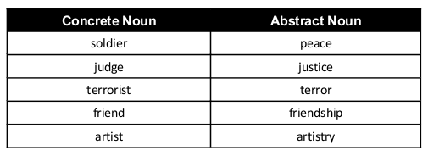

Abstract Nouns
justice beauty success goal
envy bravery love awareness
annoyance irritation happiness truth
pleasure wealth fashion sleep
fear wisdom poverty lie
trend calm appetite anger
riches generation belief fiction
loneliness care religion company
sorrow joy disregard dream
philosophy coldness hatred growth
infancy belief childhood argument
solitude confusion clarity movement
peace brilliance talent advantage
stupidity failure slavery goodness
timing luxury idea fact
kindness rhythm luck friendship
talent nap union dishonesty
freedom wit ability gain
marriage right thrill honesty
thought divorce generosity loss

