ELA – Tuesday, April 14

Online you can find links to:
Daily Warm Up – PowerPoint online
Lesson 7 vocabulary Quiz – answer online
The Interview Short Story
The Interview Questions – answer online

Math – Tuesday, April 14

Problem of the Day Work Space

Math Practice –Tuesday, April 14

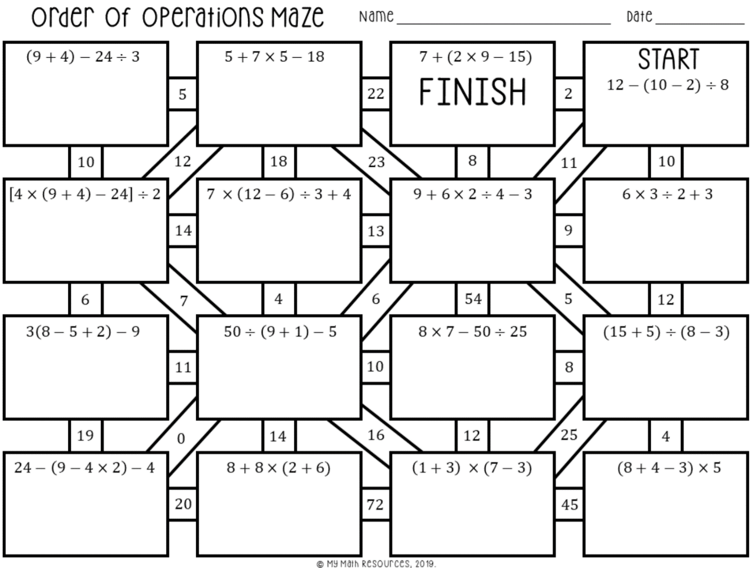

Math Practice – Tuesday, April 14

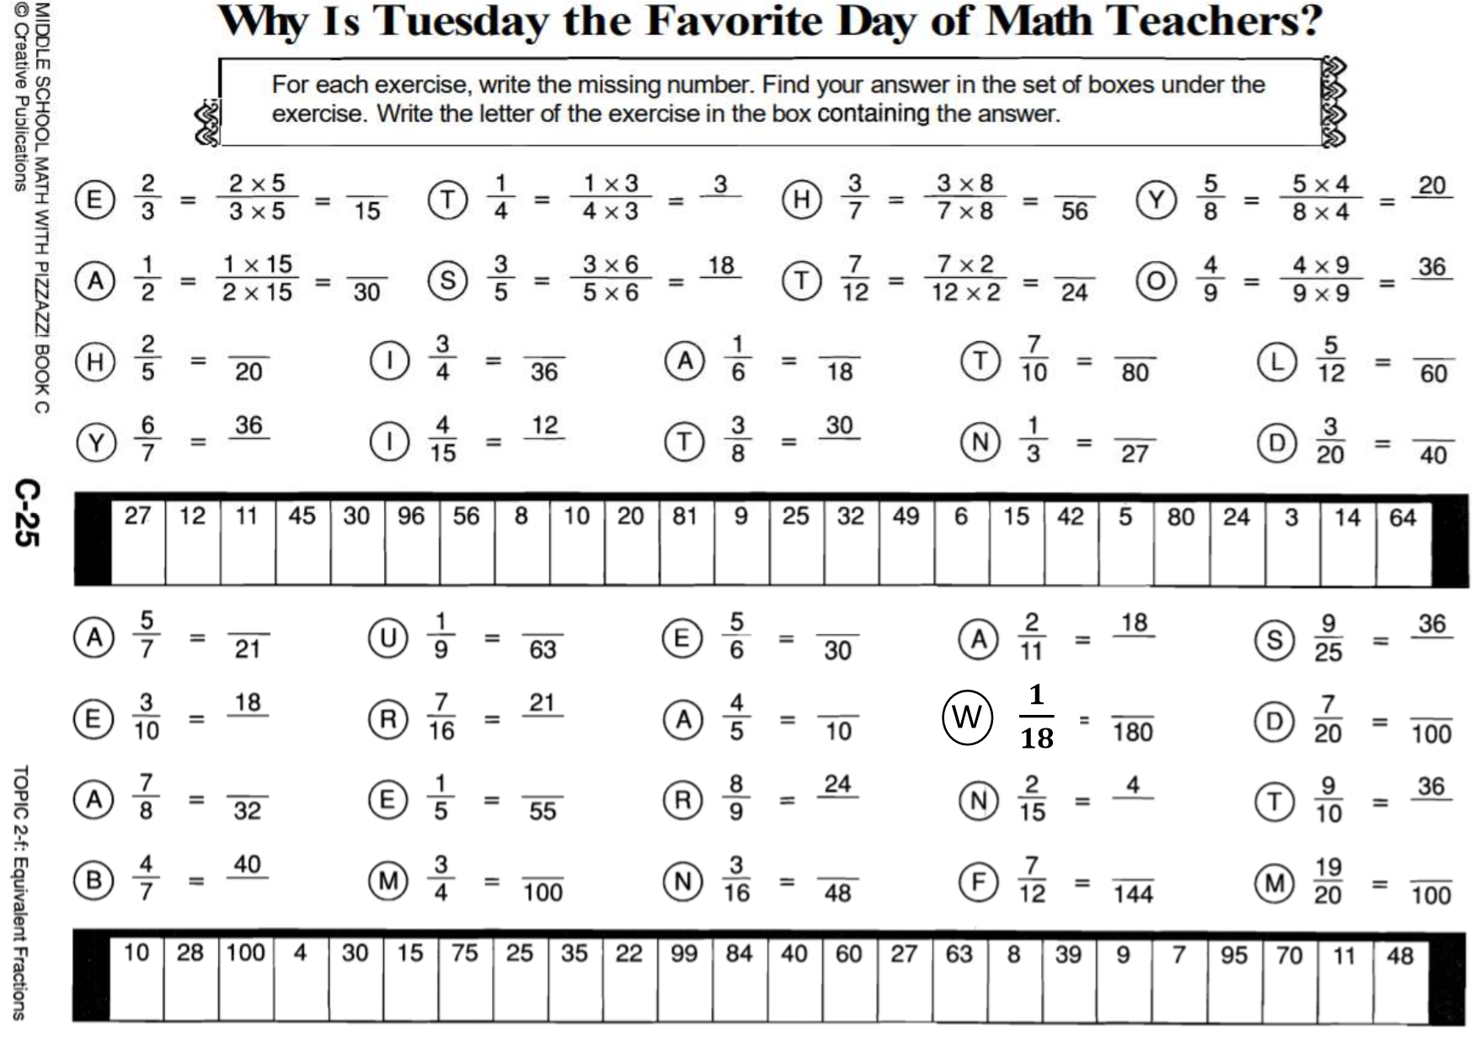

Science – Tuesday, April 14

Online, you can find links to:
Gravity and the Solar System chapter from the textbook
Gravity and the Solar System Powerpoint
Gravity and the Solar System Notes Video
Book Questions – to complete online

