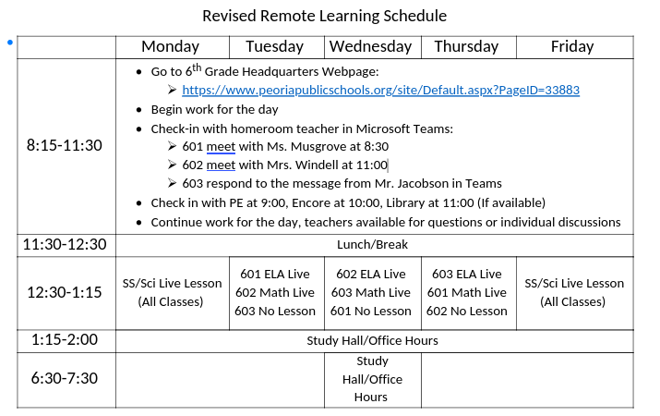

ELA – Wednesday, April 15

Online you can find links to:
Daily Warm Up – PowerPoint online
Lesson 7 vocabulary Quiz – answer online if you didn’t complete it yesterday
Eight-Ball Short Story
Eight-Ball Questions – answer online

Social Studies – Wednesday, April 15

Online, you can find links to:
A Dive into Democracy article and questions to answer online

If you didn’t finish last week:
The First Greeks Newsela article
Democracy is Born Newsela article
Questions to answer online

Math – Wednesday, April 15

Problem of the Day Work Space

Math Practice –Wednesday, April 15
