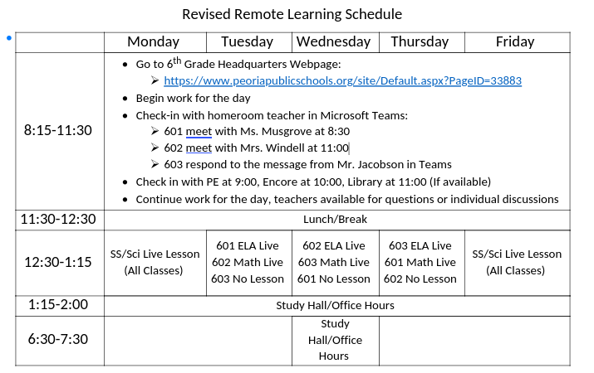

ELA – Thursday, April 16

Online you can find links to:
Daily Warm Up – PowerPoint online
Read Learning to Drive below
Learning to Drive Comprehension Questions – Answer online
Learning to Drive
Brooklyn was relaxing on her beanbag and reading the last chapter of her science fiction book when her dad opened her bedroom door and peeked his head in. “Katie and I are going to run to the store, but we should be back within twenty minutes. Will you be okay here on your own?”
Brooklyn set her book down. “Actually, can I come with you? I need to start on my book report display this afternoon, and the markers we have at home are all old and fading. Can we buy a new pack of markers?”
“Sure,” her dad answered. “Get ready and head out to the car.”
Brooklyn pulled her hair into a ponytail and slipped on her sandals. When she stepped into the garage, she glanced at the car and stopped dead in her tracks. Her dad was in the passenger seat and her 14-year-old sister was in the driver’s seat. Suddenly, Brooklyn’s hands felt sweaty. She approached her dad and knocked on the window. He lowered it. “You can go to the store without me. I know she has her learner’s permit, but I don’t feel safe when Katie drives.”
“That’s silly,” said her dad. “Your sister’s driving skills are improving. Besides, I’ll be right here beside her if she needs help. Hop in.”
Brooklyn took a deep breath and reluctantly opened the back door. She sat down, pulled her seat belt across her chest, and buckled it in place.
Katie slowly backed out of the driveway and then crept down the street. When she reached the intersection where she had to turn right, she turned too sharply, and the car went up on the curb and into the grass. Brooklyn screamed as Katie hit the brakes.
“Let me out!” Brooklyn cried. “I’m going to ride my bike to the store.”

Science – Thursday, April 16

Online, you can find links to:
Terrestrial Planets Videos and Questions

If you didn’t finish last week:
The First Greeks Newsela article
Democracy is Born Newsela article
Questions to answer online

Math – Thursday, April 16

Problem of the Day Work Space

Math Practice –Thursday, April 16 – continued from yesterday
