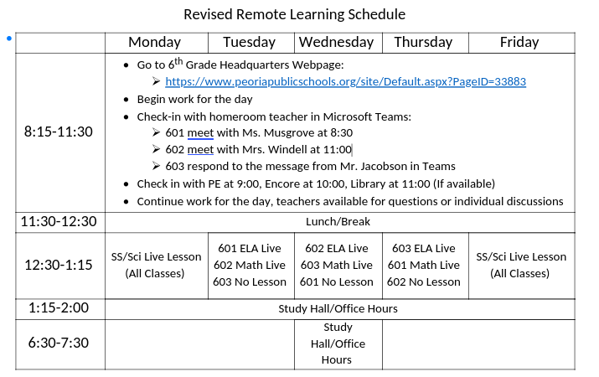

ELA – Friday, April 17

Online you can find links to:
Daily Warm Up – PowerPoint online

Social Studies – Friday, April 17

Live Lesson Today – see online link in Calendar

Math – Friday, April 17

Order of Operations Quiz - Online

Math – Friday, April 17

Problem of the Day Work Space

