The Trojan War: Real or Myth?
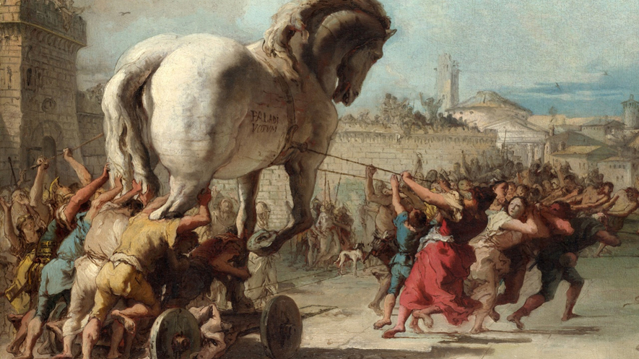
The story of the Trojan War bridges the history and mythology of ancient Greece. It has inspired the greatest writers of antiquity from Homer, Herodotus and Sophocles to Virgil.
The site of Troy was discovered in the 1800s, in what is now western Turkey. Since then, archaeologists have uncovered evidence that it was the capital of a kingdom. They believed that the city might have been destroyed around 1180 B.C., about 3,200 years ago. The site might be the basis for the tales told by Homer some 400 years later in the "Iliad" and the "Odyssey."

The Narrative of the Trojan War
The Trojan War was a conflict between the kingdoms of Troy and Mycenae in Greece. According to ancient sources, the war began after Queen Helen of Sparta was either kidnapped by Paris, a Trojan prince, or ran away with him. Helen's husband Menelaus convinced his brother Agamemnon, king of Mycenae, to lead an army to bring her back. They were joined by a group of Greek heroes and sailed to Troy with a fleet of more than a thousand ships. The Greeks laid siege to Troy and demanded Helen's return.
The war lasted more than 10 years. It ended after the Greek armies left a large wooden horse outside the gates of Troy. After much debate, the Trojans pulled the mysterious gift into the city. When night fell, the horse opened up. A group of Greek warriors, led by Odysseus, climbed out and destroyed Troy from within.
After the Trojan defeat, the Greek heroes slowly made their way home. Odysseus took 10 years to make the difficult journey home to Ithaca as recounted in the "Odyssey." Helen, whose two Trojan husbands were killed during the war, returned to Sparta to reign with Menelaus, her husband. After his death, some sources say Helen was exiled to the island of Rhodes. A widow who lost her husband in the Trojan war had her hanged.

The Trojan War Epics
Little is known about the historical Homer. Historians think the "Iliad" was completed in 750 B.C., and the "Odyssey" in 725 B.C. Both began as oral stories and were first written down decades or centuries after they were composed. Many of the most familiar episodes of the war, from the abduction of Helen to the Trojan Horse and the destruction of Troy, come from the so-called "Epic Cycle." These were narratives put together about 500 B.C.
In the first century B.C. the Roman poet Virgil composed the "Aeneid." The book is the third great epic of the ancient world inspired by the Trojan War. The "Aeneid" follows a group of Trojans led by the hero Aeneas. They leave their destroyed city, and after a series of adventures, they founded the city of Rome. Virgil's aim was partly to claim that Rome's first emperors were descended from gods and heroes.

History, Archaeology and the Trojan War
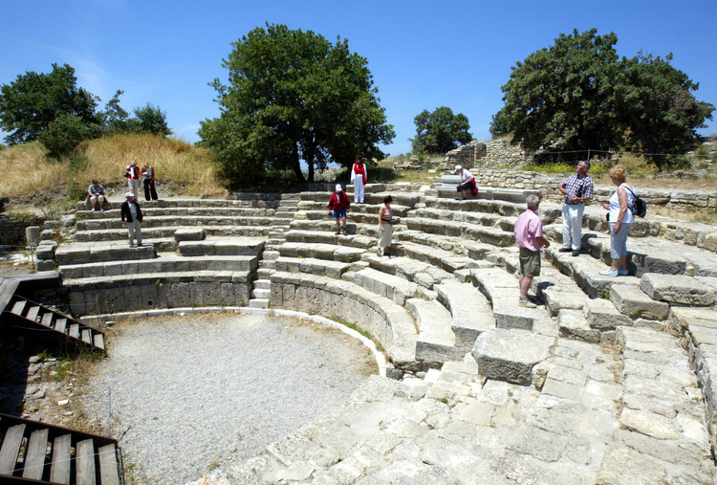
Visitors look at the amphitheater at the ancient city of Troy in the village of Tevfikiye, near the northwestern Turkish city of Canakkale, May 28, 2004. Photo by Osman Orsal for AP [Click to enlarge]
Many portions of the Trojan War clearly are not history. Several of the main characters are direct offspring of the Greek gods. Helen, for instance, was fathered by Zeus, who disguised himself as a swan. Much of the action is directed by the various competing gods. Lengthy sieges were recorded in the ancient world, but even the strongest cities could only hold out for a few months, not 10 full years.
Major excavations at the site of Troy began in 1870 under the direction of German archaeologist Heinrich Schliemann. They revealed a small citadel and layers of debris 82 feet (25 meters) deep. Later studies showed that people first began living at the site around 3000 B.C., more than 5,000 years ago. Archaeologists found evidence of buildings dating to 46 different periods of time. The site was finally abandoned in 1350.
Troy was an important Bronze Age city. Recent excavations have shown an inhabited area 10 times the size of the citadel. A layer of the excavation, dating to about 1180 B.C., reveals charred debris and scattered skeletons. It is evidence of a wartime destruction of the city and might have inspired portions of the story of the Trojan War.
In Homer's day, 400 years later, its ruins would still have been visible.

