ELA – Monday, April 6

Daily Warm Up

ELA – Monday, April 6

Lesson 7 Vocabulary
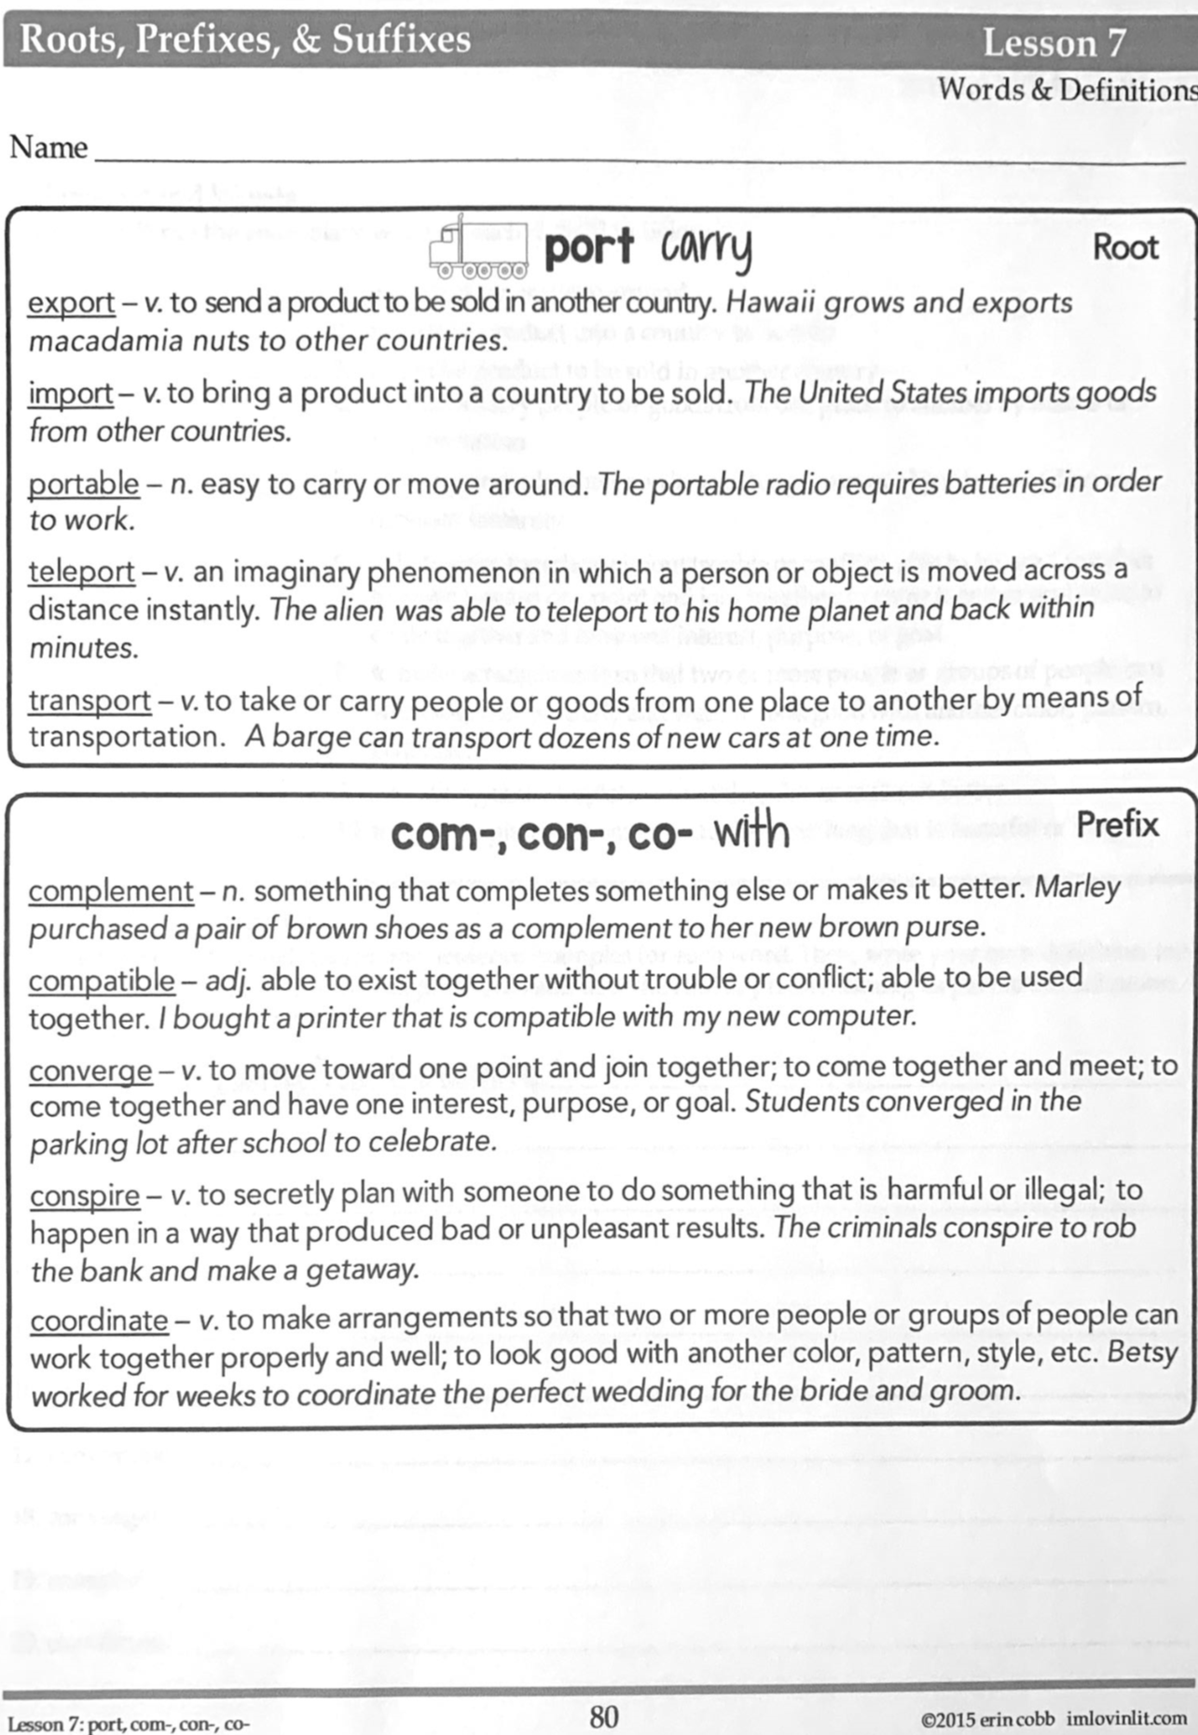

ELA – Monday, April 6

Lesson 7 Vocabulary
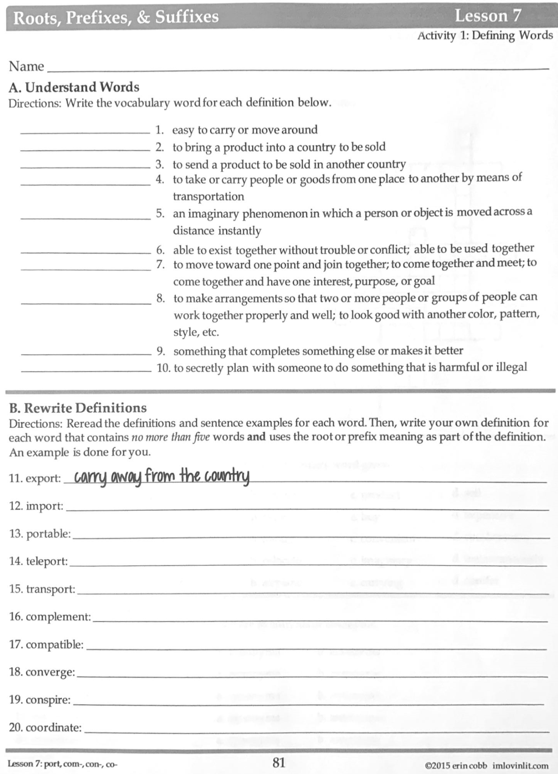

Math – Monday, April 6

Problem of the Day Work Space
Math Practice – April 6

Watch Khan Academy Video on Order of Operations.
For addition and subtraction, just complete left to right.
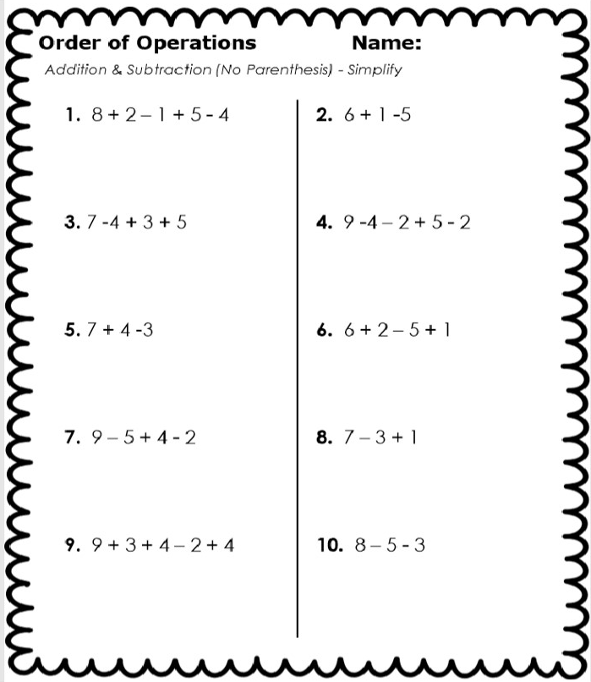

Math Practice – April 6

Complete parentheses first.
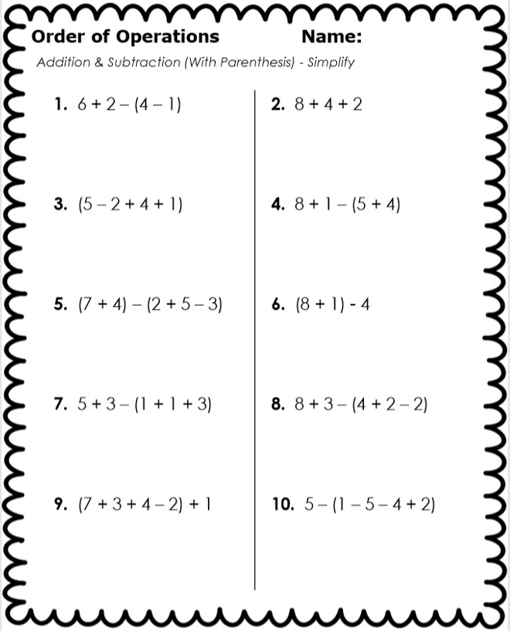

Social Studies – Monday, April 6

Ancient Greece 101 Video Questions

DIRECTIONS: Answer the questions as you watch the video. Watch again if necessary.

1. How long ago was Ancient Greece "born

2. What was the furthest east and west that Ancient Greece reached?

3. What were small Greek territories with their own rulers called?

4. What was invented in Athens?

5. Greek city-states took pride in their militaries, especially which one?

6. Who wrote the Iliad? Look carefully.

7. What physical competitions were born in Ancient Greece?

8. Which of the following was not a type of column used by the Ancient Greeks in their
architecture?

9. What was the name for studying reasons, ethics, and natural law?

10. How old is the Greek language?

Social Studies – Monday, April 6

11. Provide an example of one of the forces of history (INSPECT) that you notice in the video. Which force did you notice? Why is what you noticed an example of that force?

Example: The Greek language is an example of culture because it allowed the Greeks to communicate and write down their history.

12. Provide an example of one of the forces of history (INSPECT) that you notice in the video. Which force did you notice? Why is what you noticed an example of that force?

Example: The Greek city-state is an example of politics because it is how they organized their government and authority.

