ELA Daily Warm Up - Tuesday, April 7

ELA – Tuesday, April 7

Lesson 7 Vocabulary
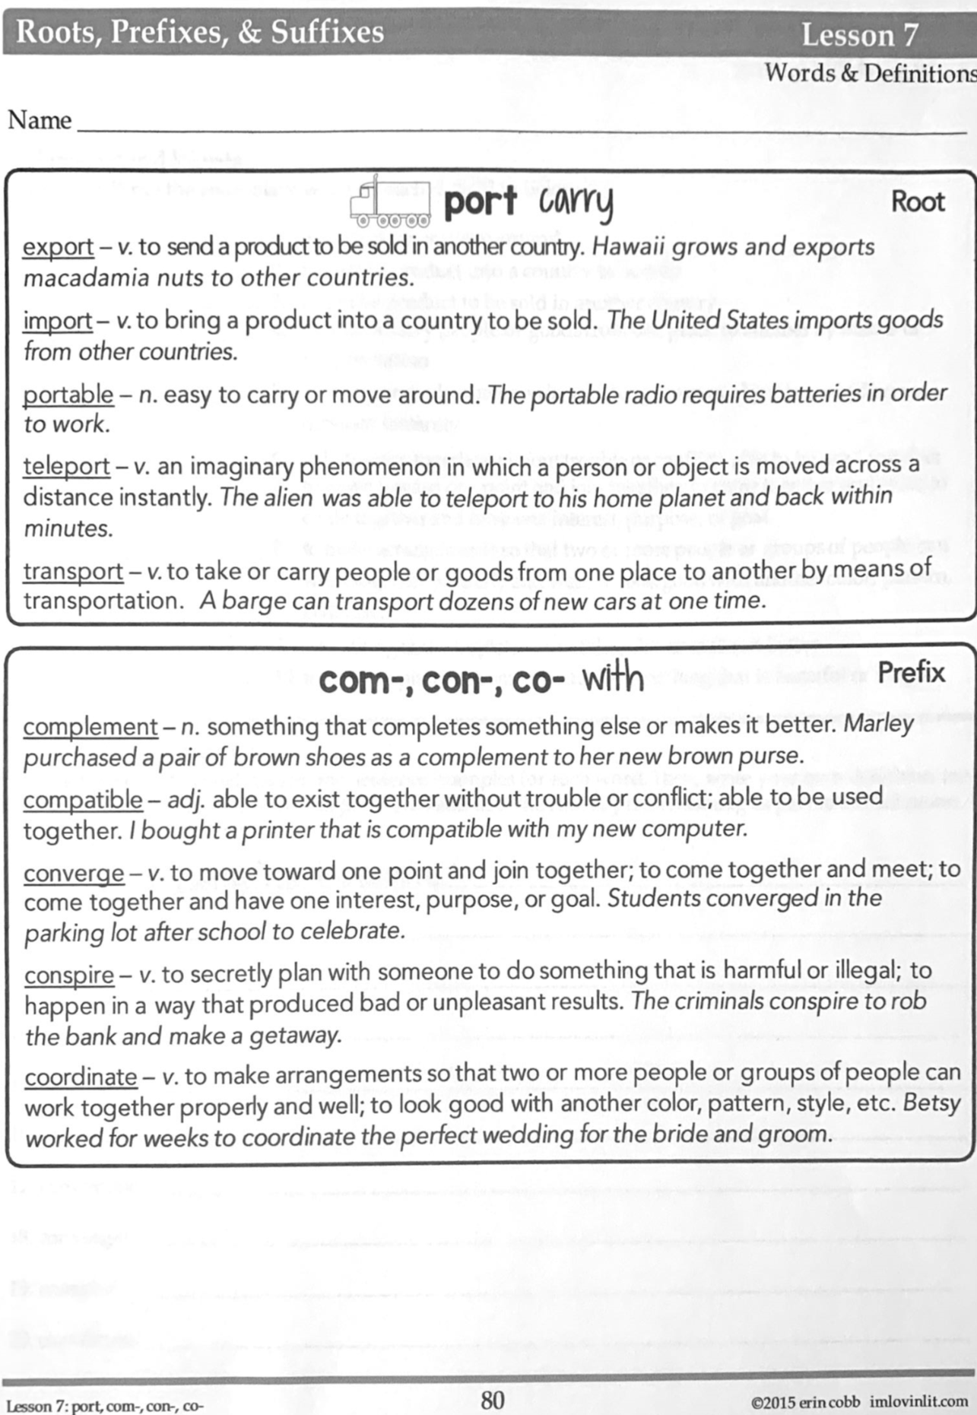

ELA – Tuesday, April 7

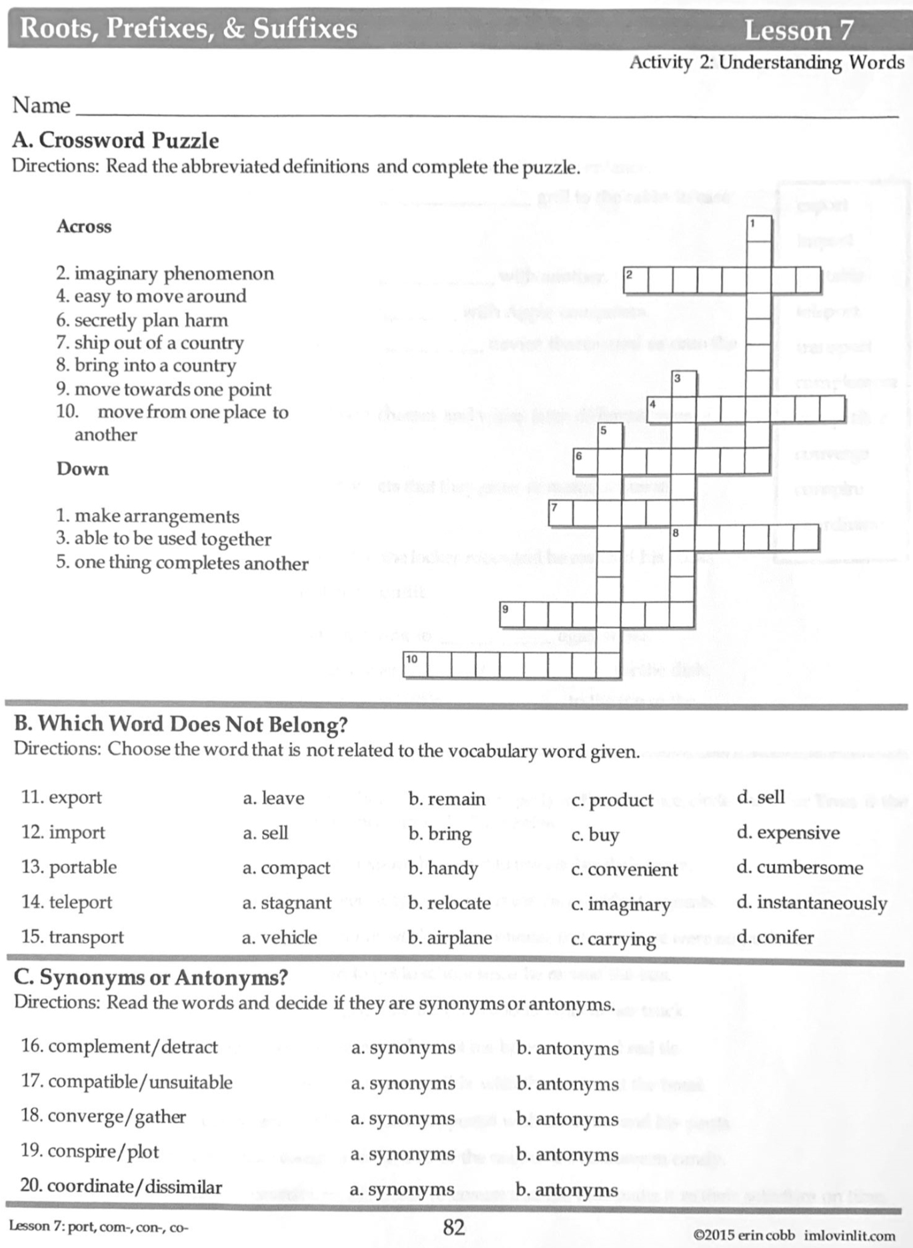

Math – Tuesday, April 7

Problem of the Day Work Space

Math Practice –Tuesday, April 7

Watch Khan Academy Video on Order of Operations.
For addition and subtraction, just complete left to right.
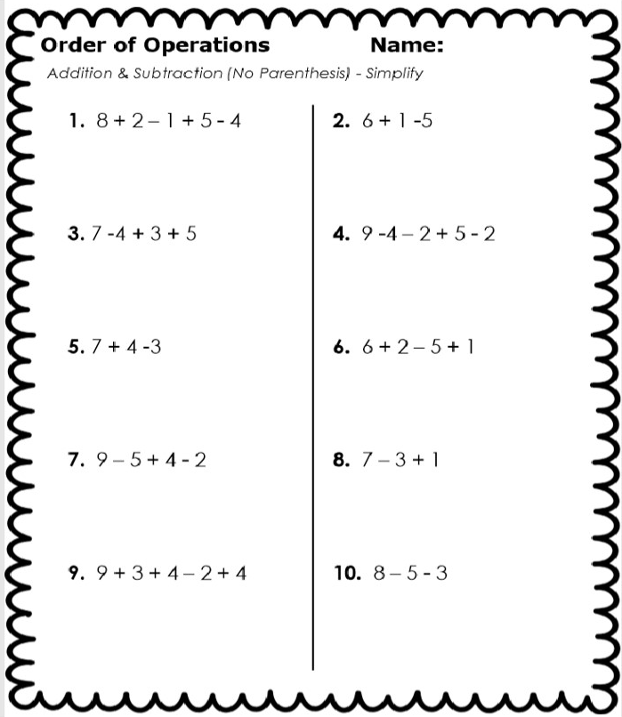

Math Practice – Tuesday, April 7

Complete parentheses first.
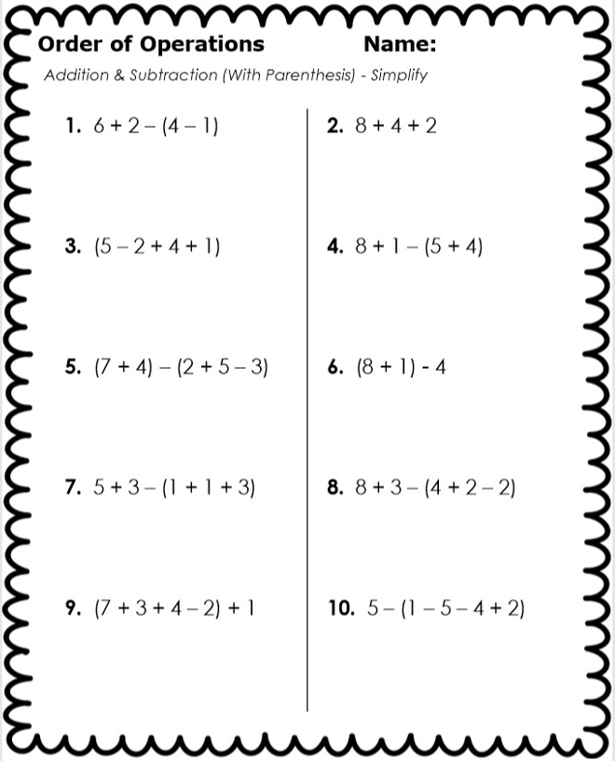

Science – Tuesday, April 7

Defining Gravity Video
Solar System Video
Gravity and Solar System Questions – complete and submit online

1.Name two things that wouldn't be on Earth if there was no gravity.
2.What was Sir Isaac Newton the first to do?
3.What did Newton discover is true about objects that go up?
4.Where does gravity pull all objects on the Earth?

