ELA Daily Warm Up – Wednesday, April 8

ELA – Wednesday, April 8

Lesson 7 Vocabulary
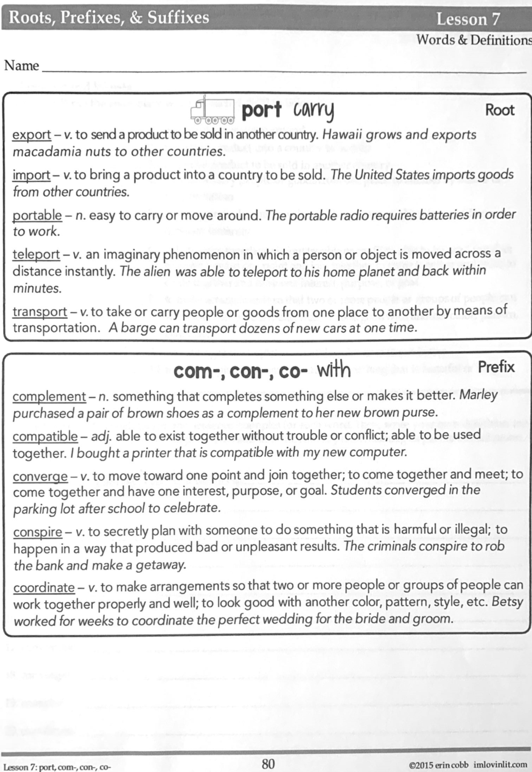

ELA – Wednesday, April 8

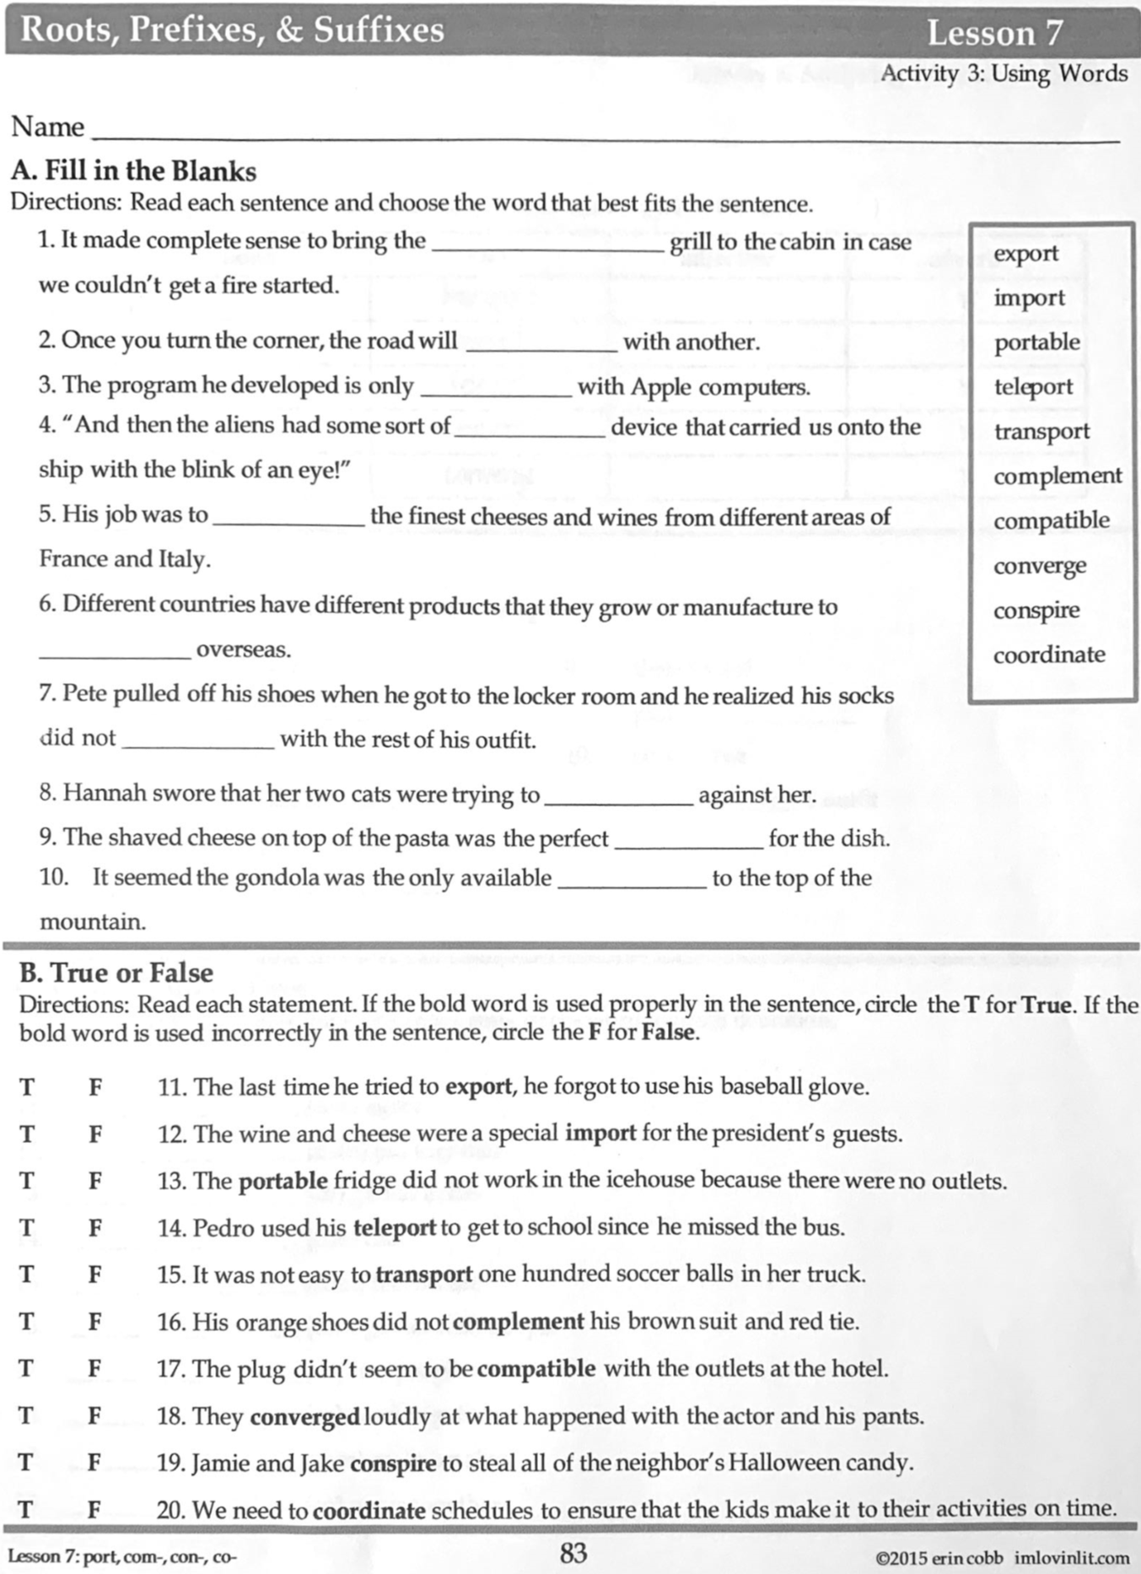

Math – Wednesday, April 8

Problem of the Day Work Space

Math Practice –Wednesday, April 8 – continued from Monday

Watch Khan Academy Video on Order of Operations.
For addition and subtraction, just complete left to right.

Math Practice – Wednesday, April 8 – continued from Monday

Complete parentheses first.

Social Studies – Wednesday, April 8

World History

Ancient Greece: The first Greeks
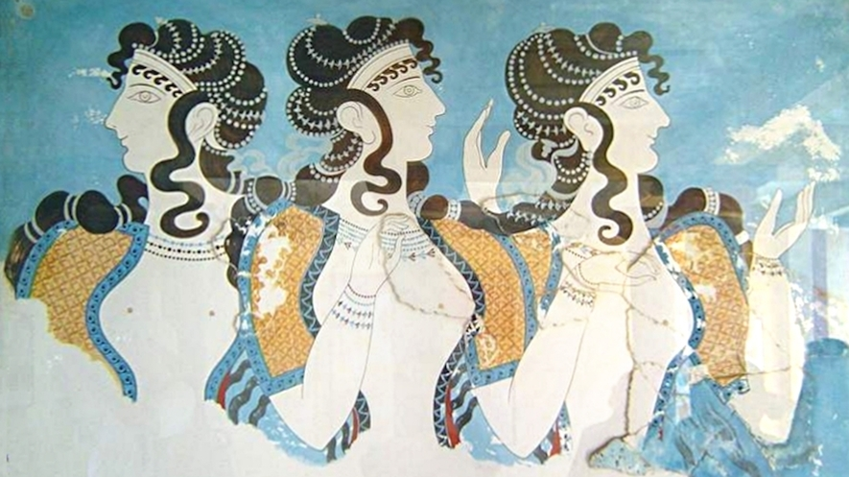A wall painting from a palace at Knossos. This is a large archaeological site on the island of Crete. The Minoans lived there more than 3,500 years ago. Image from: Wikimedia Commons.
By USHistory.org, adapted by Newsela staff
Published:04/03/2017
Democracy. Philosophy. The Olympic Games.
These are some things that first began in ancient Greece. This is what we call the Greece of long ago. The ancient Greeks lived more than 2,000 years ago.
Ideas from ancient Greece are still important today. They help us understand science and art. They have helped create fairer governments.
Ancient Greece is often called the birthplace of Western civilization. Western civilization refers to ideas that came from Europe.

A Celebration Of Humans
The Greeks believed humans were very important. They celebrated humans in their stories and art. Even their gods were made to look like humans. The Greek gods had human feelings. They acted more like flawed people than like perfect gods.
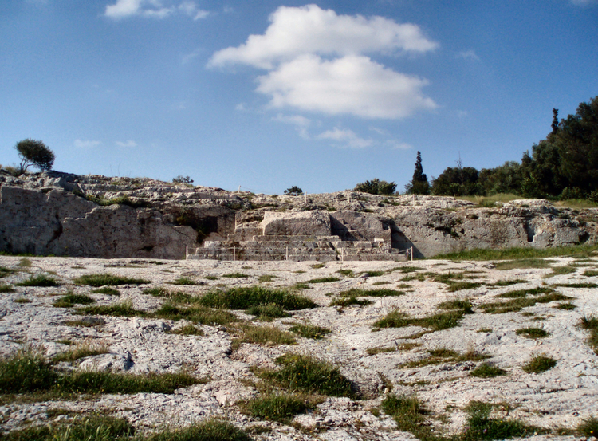
The Pnyx is a hill in Athens. The ancient Greeks would gather there to hold democratic gatherings. It is one of the most important sites in the creation of democracy. Photo from: Wikimedia Commons.
The Greeks were the first to test the idea of democracy. This is a form of government where the people rule. In a democracy, people make decisions together. They meet to talk about laws. Then they vote to decide which laws to put into place. Many democracies in the world today are based on Greek democracy.

First Came The Minoans
The first groups to live in ancient Greece were the Minoans and the Mycenaeans. Not much is known about either group. But historians know that the Minoans lived on the island of Crete. They lived there more than 3,500 years ago. The Minoans were traders who sailed the seas.

Then Came The Mycenaeans
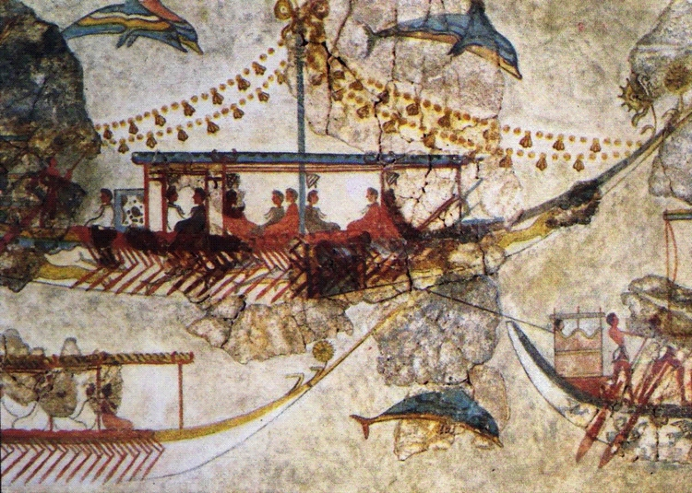
A wall painting from a Minoan settlement shows the Minoan trading ships. The settlement dates back to 3200 B.C., more than 5,000 years ago. Photo from: Universal History Archive/Getty Images.
The Mycenaeans first came from India. They traveled through the Middle East and into Greece about 4,000 years ago. Over time, both the Minoans and the Mycenaeans expanded. They took over new land to grow their territory. Eventually the two groups ran into each other.

The Dark Age Before The Enlightenment
Historians think the Mycenaeans destroyed the Minoans. Later, a group called the Dorians destroyed the Mycenaeans. This led to a "dark age" that lasted a few hundred years. During this time, civilization began to disappear in the area. Not much is known about this period in Greek history.
Later, a new group appeared in the area. They developed important ideas related to art, medicine and science. These ancient Greek ideas would shape humankind for the next 2,500 years.

Social Studies – Wednesday, April 8, 2020

World History

Ancient Greece: Democracy is born
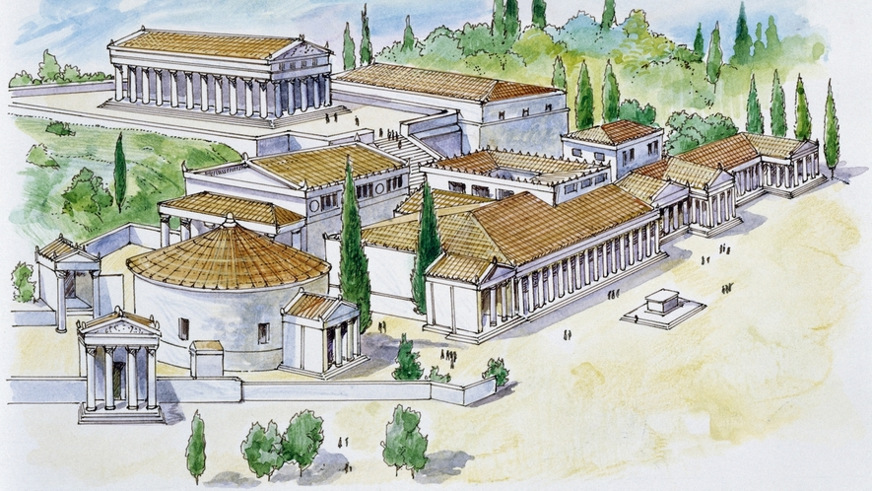Image 1. An illustration of the agora of Athens in Ancient Greece. The agora was a large open space in the center of the city. The assembly meetings of early Greek democracy took place here. Photo by DeAgostini/Getty Images
By USHistory.org, adapted by Newsela staff
Published:04/05/2017
Ancient Greece was made up of several small cities. Each one had its own government. Athens was an important city in ancient Greece. In Athens, the people created the very first democracy. Their democracy began about 2,500 years ago. In a democracy, citizens are given the right to vote. They work together to run the government.
Not everyone in Athens was considered a citizen, though. Only free men over 18 years old were citizens. Women were not. Neither were slaves or foreigners. They were not permitted to vote or take part in government at all. This meant that only a small number of people in Athens were citizens. Democracy only existed for this very small group of men.

Solon Made Changes To Government
Athens was not always a democracy. At first, it was ruled by a small group of rich people. Then a man named Solon made changes to the government. These changes helped poor people have a larger voice. Poor citizens were allowed to sit in the assembly and vote. The assembly was a group that decided how to run the city.
Later, a man named Cleisthenes made even more changes. He gave every citizen equal rights. He also created a group of lawmakers for Athens. These lawmakers were picked randomly. Anyone who was a citizen might be picked to be a lawmaker.
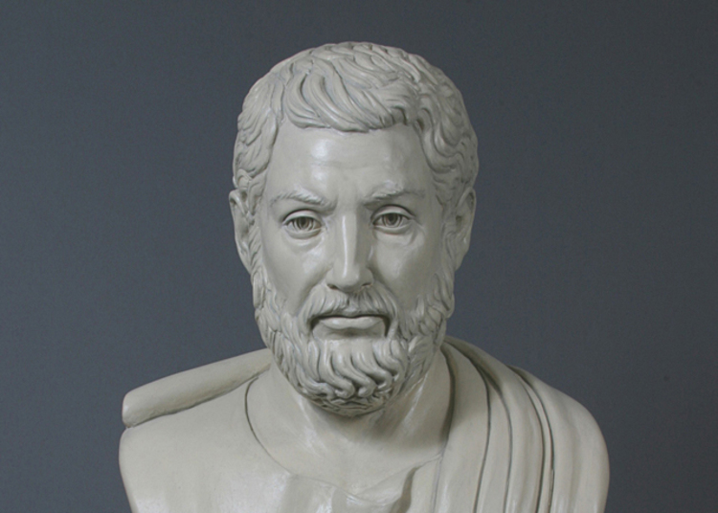
A bust of Cleisthenes completed by sculptor Anna Christoforidis at the Ohio Statehouse in Columbus, Ohio. He is called the "father of Athenian democracy." Photo from: Ohio Statehouse/Capitol Square Review and Advisory Board.

The Agora In Athens
The assembly meetings took place in the agora. This was a large open space in the middle of Athens. During the meetings, citizens were free to share their opinions. Then they were expected to cast their votes. This was how they decided what the government should do.
The citizens made decisions by majority rule. This means they did whatever won the most votes. The democracy depended on every citizen doing his duty. All citizens were expected to vote. They were also expected to serve in the government if they were needed. If they did not do these things, they would get in trouble.
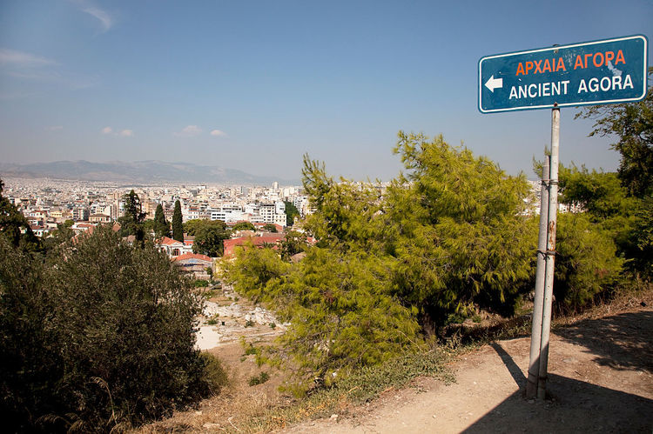
A sign in Athens, Greece pointing to the Ancient Agora. While it is now in ruins, it was once a place of political, educational and cultural value. Photo from: Mike Kemp/In Pictures Ltd./Corbis via Getty Images.

Bigger Populations Mean Representative Governments
Democracies today are different. In the United States, people do not have to take part in government. If they do not want to vote, they do not have to.
In Athens, they had a pure democracy. Every citizen voted on every important decision. As cities got bigger, this became harder to do. There were too many people and too many decisions to make. So people started to vote for lawmakers instead. The lawmakers made decisions for them. This is how most democracies work today.

