ELA Daily Warm Up – Thursday, April 9

ELA – Thursday, April 9

Lesson 7 Vocabulary
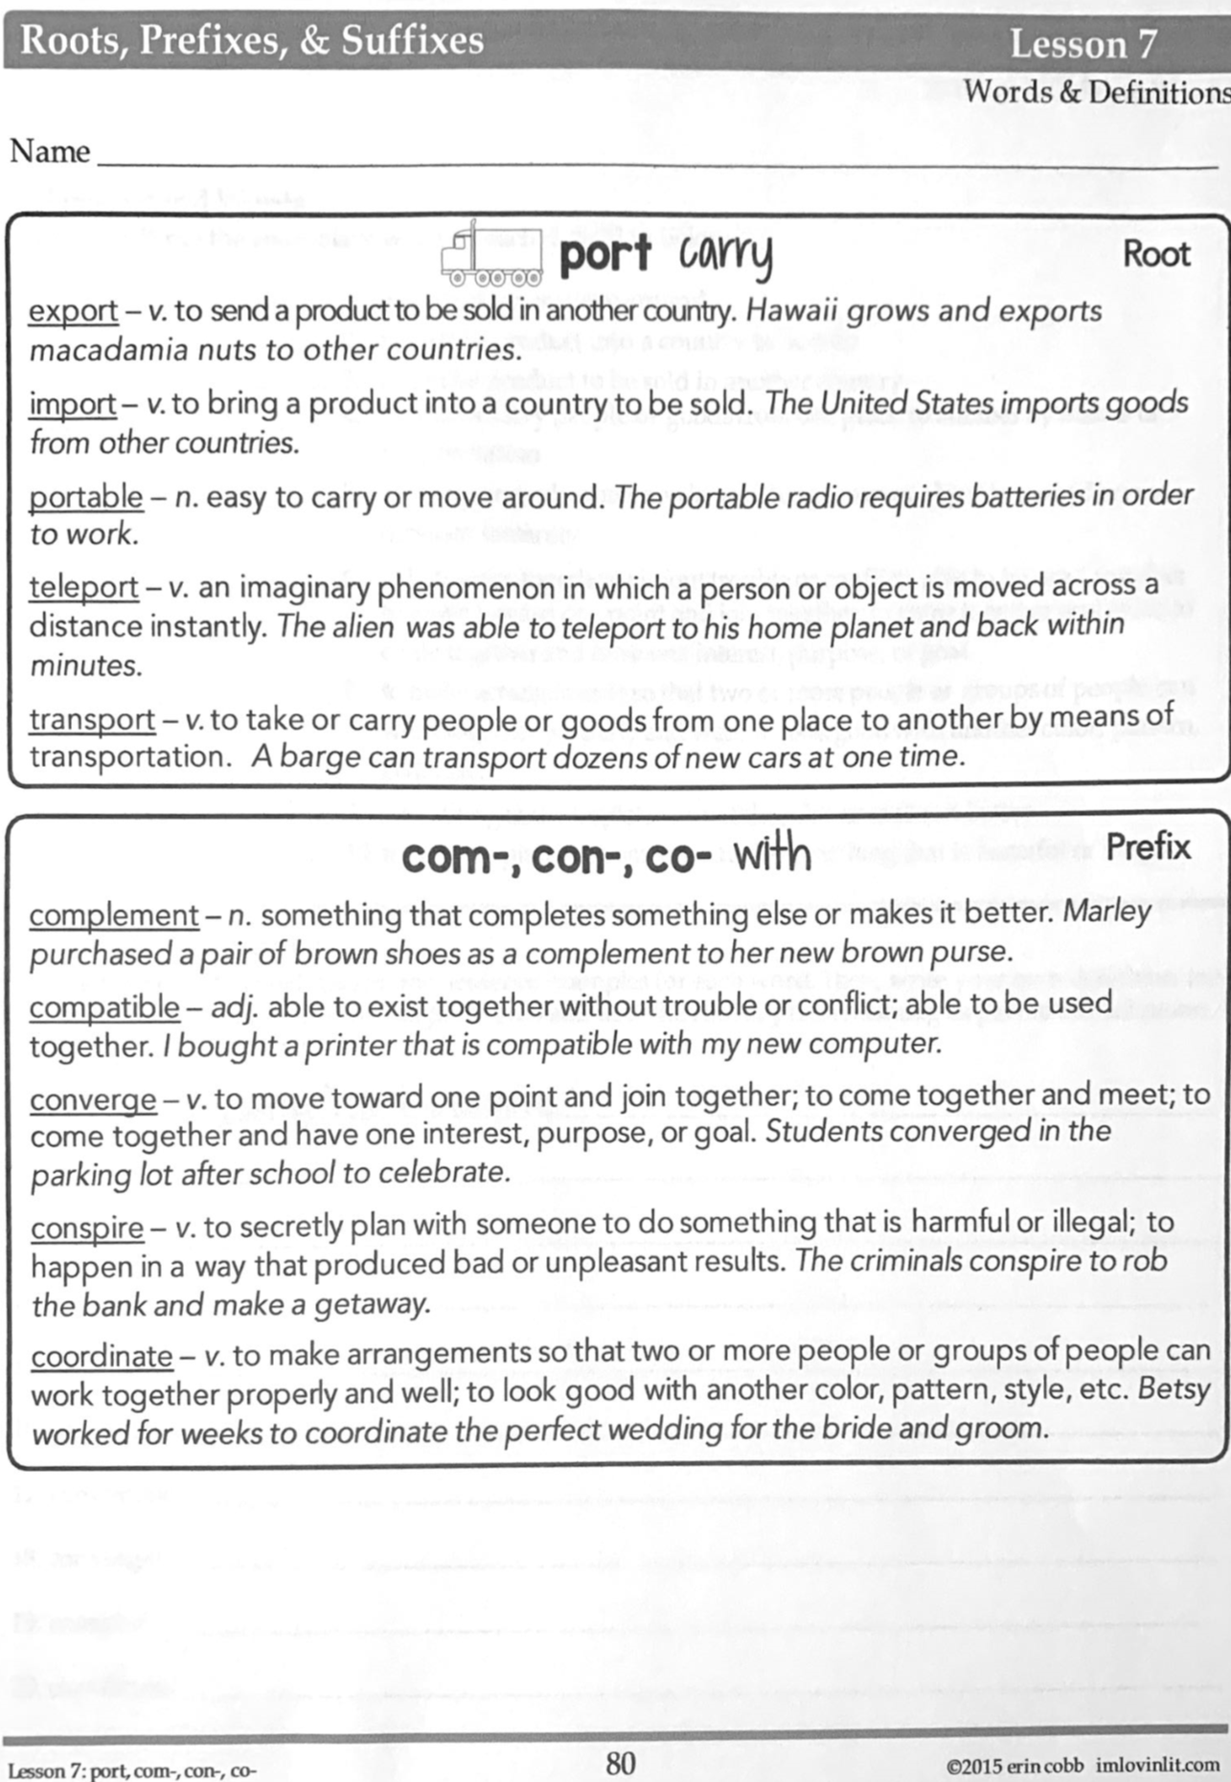

ELA – Thursday, April 9

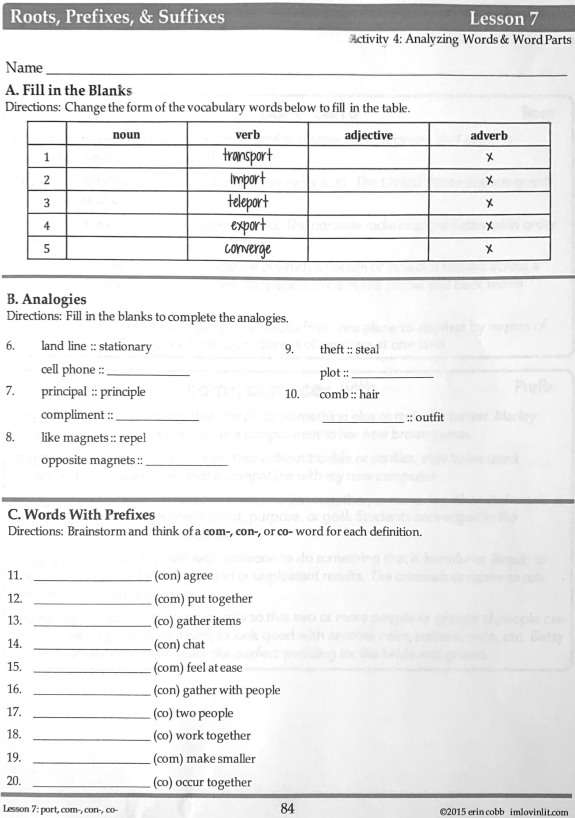

Math – Thursday, April 9

Problem of the Day Work Space

Math Practice –Thursday, April 9 – continued from Monday

Watch Khan Academy Video on Order of Operations.
For addition and subtraction, just complete left to right.
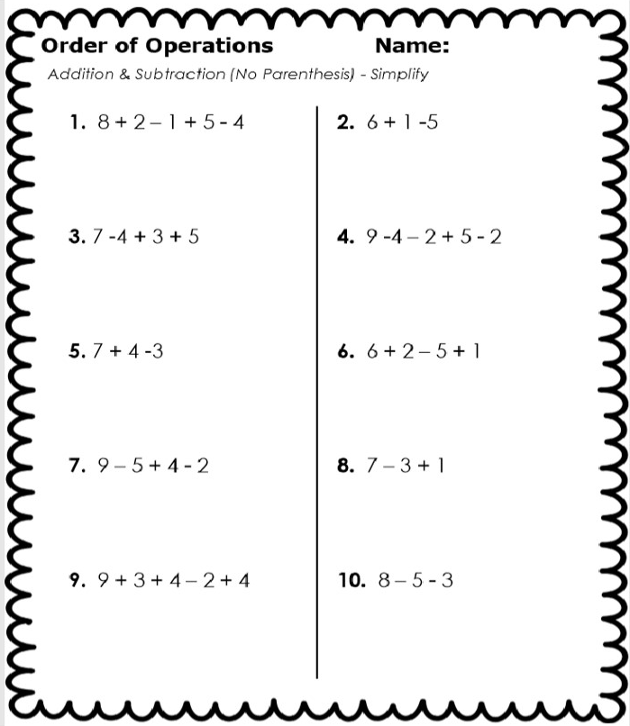

Math Practice – Thursday, April 9 – continued from Monday

Complete parentheses first.
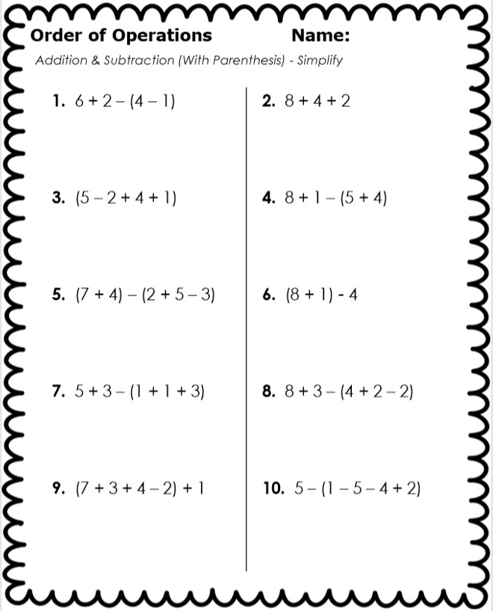

Science – Thursday, April 9

Live Science Demonstration 1:00
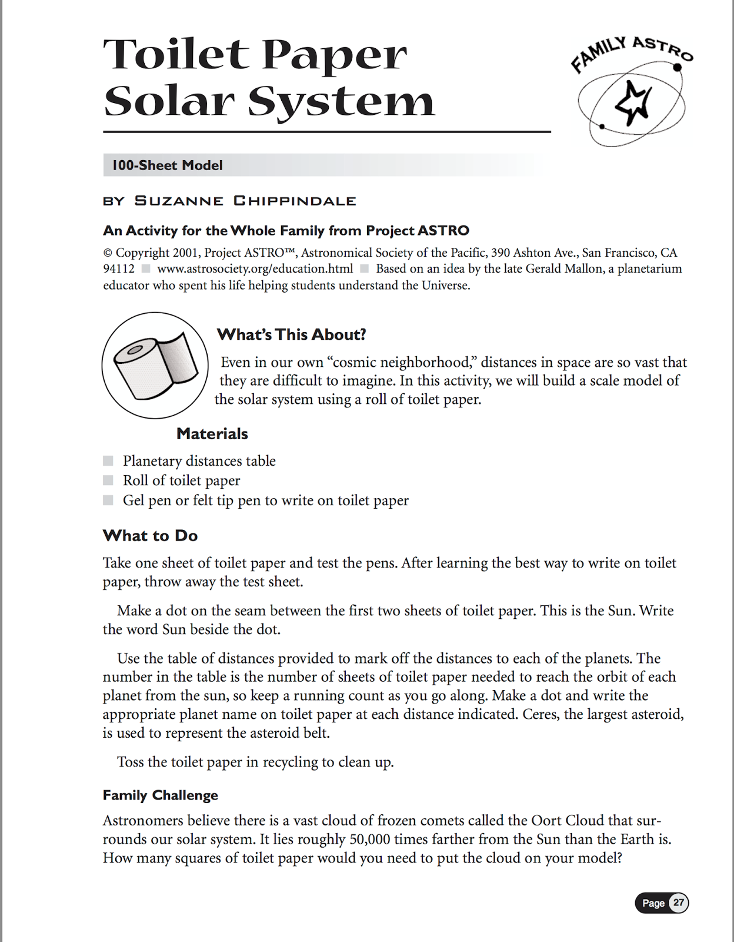

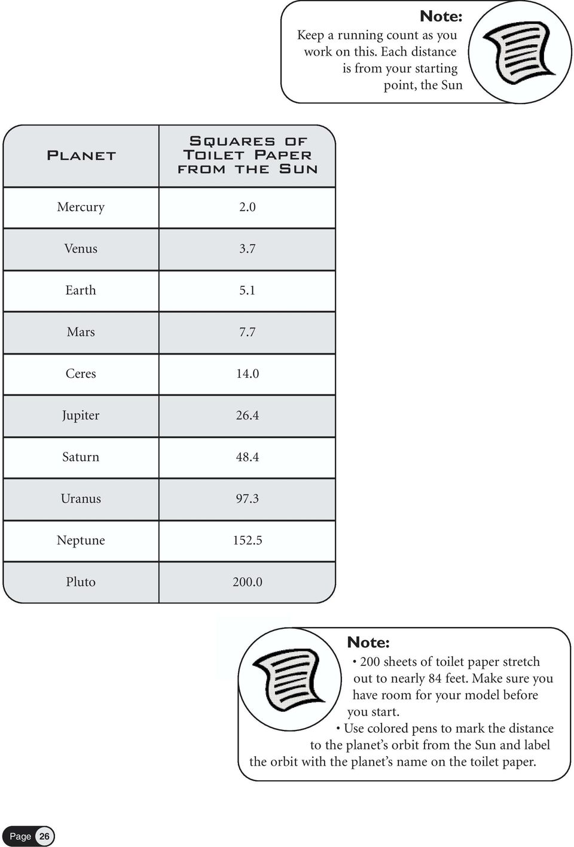
Science – Thursday, April 9

Online, you can find links to:
Gravity and the Solar System chapter from the textbook
Gravity and the Solar System Powerpoint notes
Questions from the Toilet Paper Demonstration

