ASSIGNMENT #6
FOCUS: Persuasive Techniques and Rhetorical Strategies
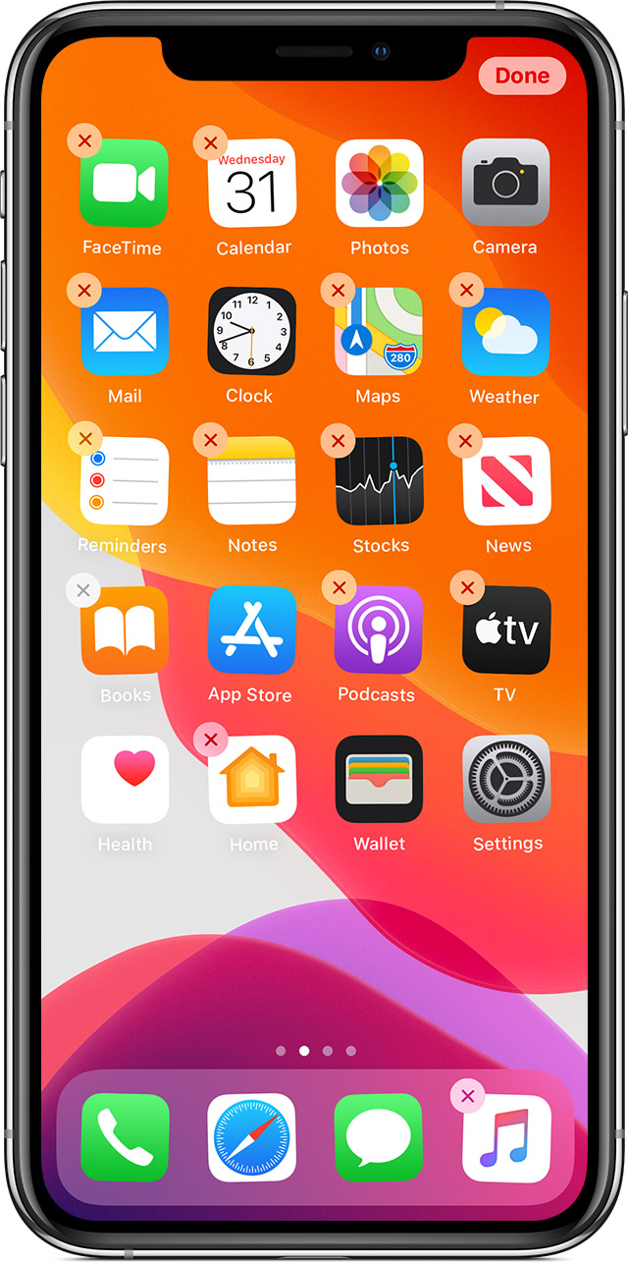
Your Task: Design an app that you wish existed during this time of social distancing where we are all stuck at home. Then, pitch your idea to me using persuasive techniques and rhetorical strategies to “sell” me on your idea/concept!

Step 1: Brainstorm some general app ideas. Think: What is currently missing from this market? What do you wish existed? Why?
What is your app called?
What does your app do?
Who is your “target audience”?
What current issue/problem does your app “solve”?
Step 2: Narrow down your general app concept/idea.

NAME OF TYPE | DEFINITION | EXAMPLE USING YOUR APP
Step 3: CLICK HERE and HERE for two great lists of persuasive techniques used in advertising. Choose at least THREE specific techniques to use in your “pitch” and name/list them below. Please color code the techniques so I can see where/when/how you use them in your pitch.

Step 4: Pitch/sell me your app - Don’t forget to color code your persuasive techniques wherever you utilize them! This can be organized as an “ad” or written as a traditional paragraph.

Step 5: Download this document and submit it using MS Teams for me to read, respond to, and grade!

