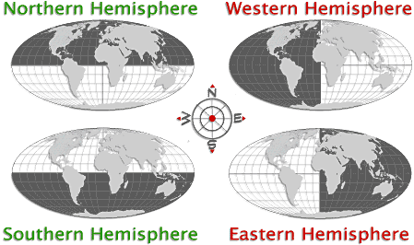

Hemispheres

List the continents and oceans for each hemisphere.

Northern Hemisphere

Southern Hemisphere

Eastern Hemisphere

Western Hemisphere

