Vocabulary Lesson 7 – Week of April 6, 2020

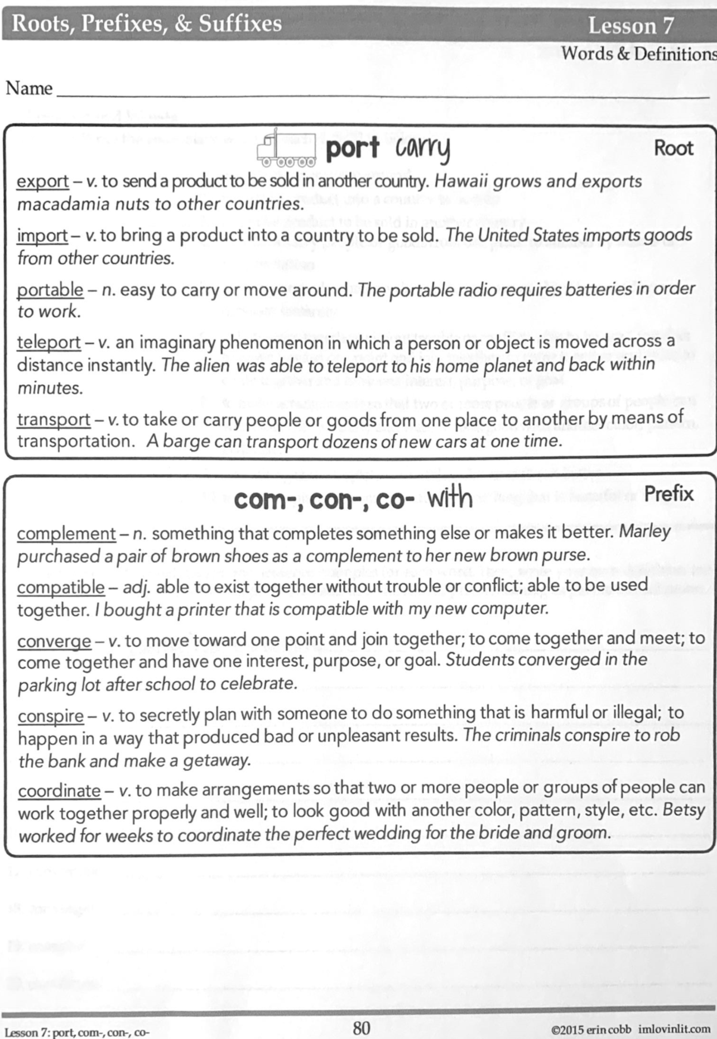
Vocabulary Lesson 7 – Week of April 6, 2020

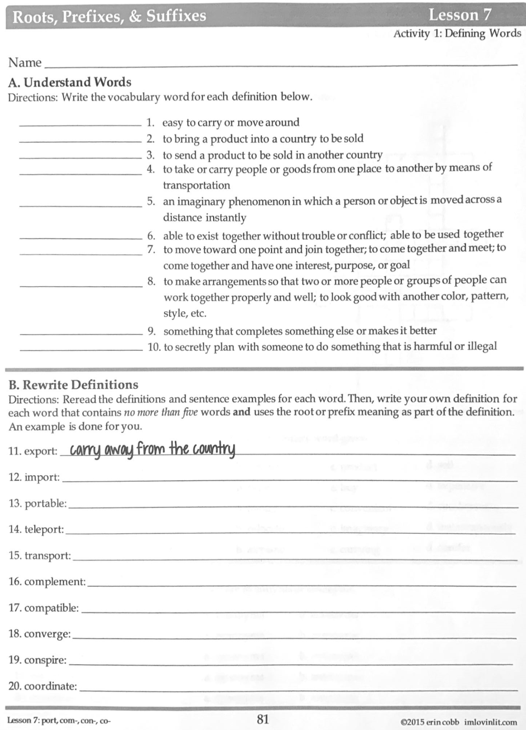

Vocabulary Lesson 7 – Week of April 6, 2020

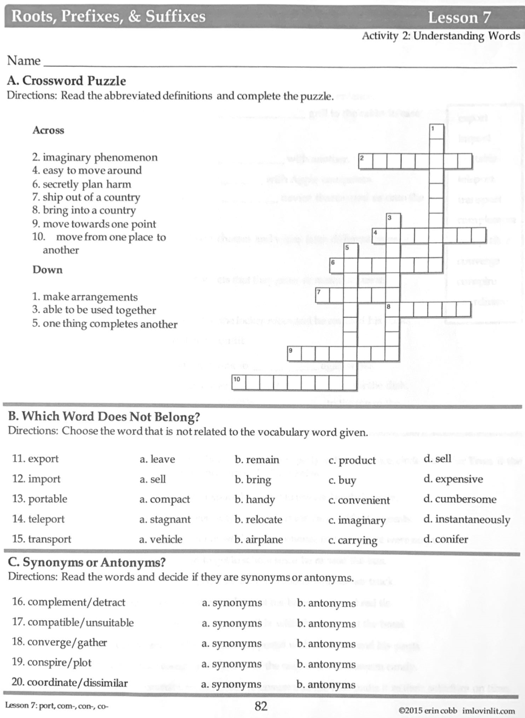

Vocabulary Lesson 7 – Week of April 6, 2020

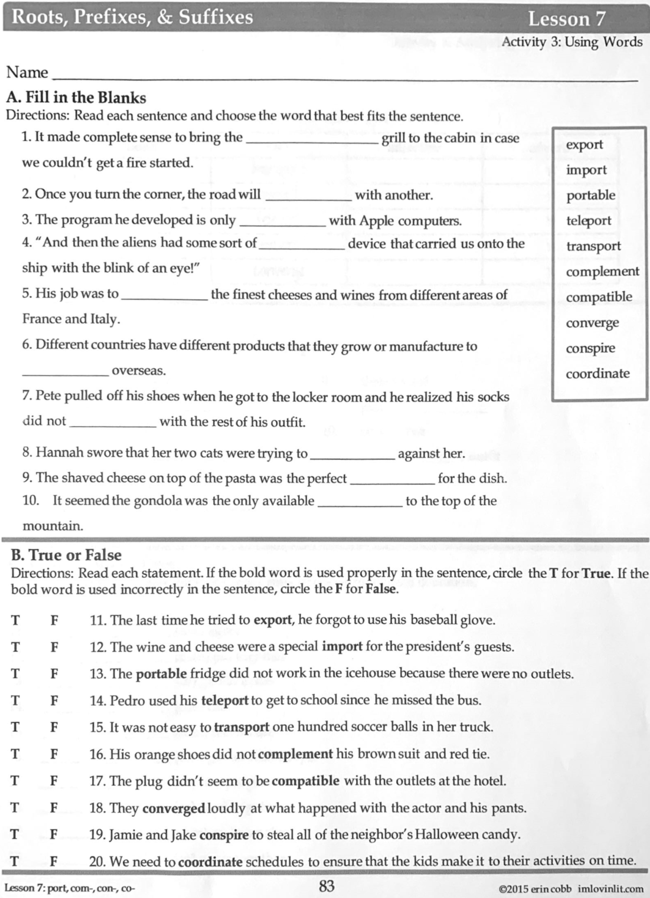

Vocabulary Lesson 7 – Week of April 6, 2020

