World Leaders: Alexander the Great
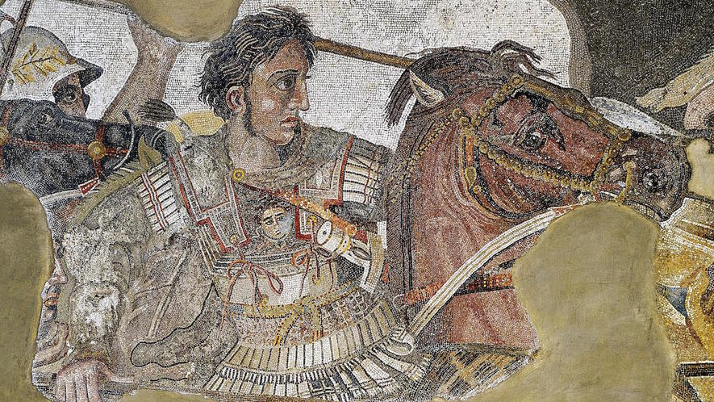
Synopsis: King of Macedonia and conqueror of the then-known world, Alexander the Great was born on July 20, 356 B.C., in Pella, Macedonia. From 336 to 323 B.C., he united the Greek city-states and led the Corinthian League. He also became the king of Persia, Babylon and Asia, and created Macedonian colonies in the region. While considering conquering Carthage and Rome, Alexander died of malaria in Babylon, in present-day Iraq, on June 13, 323 B.C.

Early Life
Alexander the Great was born in Macedonia on July 20, 356 B.C, about 2,300 years ago. Macedonia is now part of Greece. His parents were King Philip II of Macedon and Queen Olympia. Alexander had dark eyes and curly hair. He hardly ever saw his father, who spent most of his time at war. Although Olympia served as an important role model, Alexander became resentful that his father was not around.
Alexander's first teacher was Leonidas. He had been hired by King Philip II to teach Alexander math, horsemanship and archery. Alexander was restless and behaved badly, and Leonidas struggled to control him. Alexander's next teacher was Lysimachus, who used role-playing games to get the boy's attention. Alexander especially liked pretending to be the warrior Achilles.
King Philip II hired Aristotle, a famous thinker and philosopher, to teach Alexander. They read Homer's Iliad, a poem about war, and Alexander decided to become a heroic warrior. Aristotle wrote a short version of the Iliad for Alexander to carry to war.
When Alexander was still just a teen, he became a soldier. A year later, Alexander helped his father defeat the armies of Thebes and Athens, Greek city-states. The relationship between father and son fell apart. King Philip II married a princess named Cleopatra Eurydice and forced Alexander's mother, Olympia, to leave. Alexander and Olympia fled Macedonia and stayed with her family.

King of Macedonia
In 336, Alexander's sister married a king. During a festival afterward, King Philip II was murdered.
Alexander was 19 years old at the time. After his father's death, Alexander decided to become king any way he could. He gained the support of the Macedonian army. It proclaimed Alexander the king and helped him kill anyone else who wanted to be king. Olympia helped her son by killing the daughter of King Philip II and Cleopatra.
The southern Greek states celebrated King Philip II's death and tried to break free of Macedonia.

Campaigns and Conquests
Alexander received the news that Thebes, a Greek city-state, had forced out the Macedonian soldiers. Alexander did not want the other city-states to rebel, and marched his huge army south all the way to the tip of Greece. He had 3,000 horsemen and 30,000 soldiers.
Alexander and his army destroyed Thebes. He wanted to send a message to other cities not to rebel. The other Greek city-states paid attention, and became allies of the Macedonian Empire or stayed out of the conflict.
Alexander defeated King Darius III of Persia twice. Darius fled, and Alexander declared himself the king of Persia.
Next, he won Egypt, which gave up without fighting. He created the city of Alexandria, and it became a center for Greek arts, ideas and business.
Alexander next conquered eastern Iran. After capturing the prince, Alexander married the prince's daughter, Rhoxana. He also defeated India.
When Alexander was about 31, he reached the city of Susa in Persia. He was worried that he would be overthrown as the leader. He also wanted to get more soldiers. He commanded many Macedonians to marry Persian princesses. Alexander hired tens of thousands of Persian soldiers for his army, and then fired many Macedonian soldiers. This angered the soldiers. They spoke badly about Alexander's new troops and complained that he was becoming too Persian.

Death
Alexander died on June 13, 323 B.C., in Babylonia, which is now in Iraq. He had malaria, which is a disease. He was just 32 years old. Rhoxana gave birth to his son a few months later.
After Alexander died, his empire collapsed. The nations in it fought for power. Over time, the arts and ideas of Greece and Asia mixed and thrived. It was a gift Alexander gave to the world.

