Problem of the Day – Week of April 6

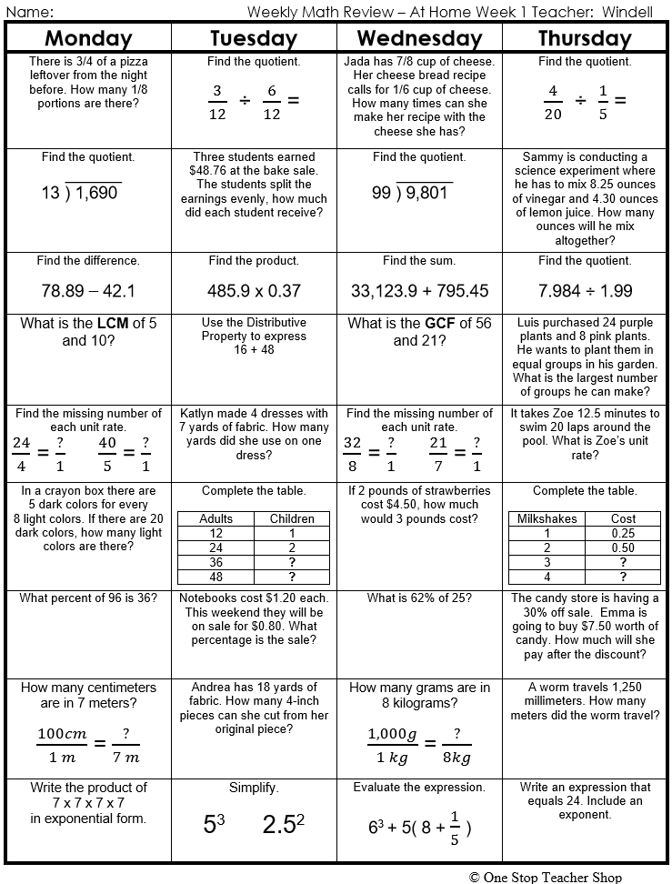

Problem of the Day – Week of April 6

