The Watson’s go to Birmingham – Webquest

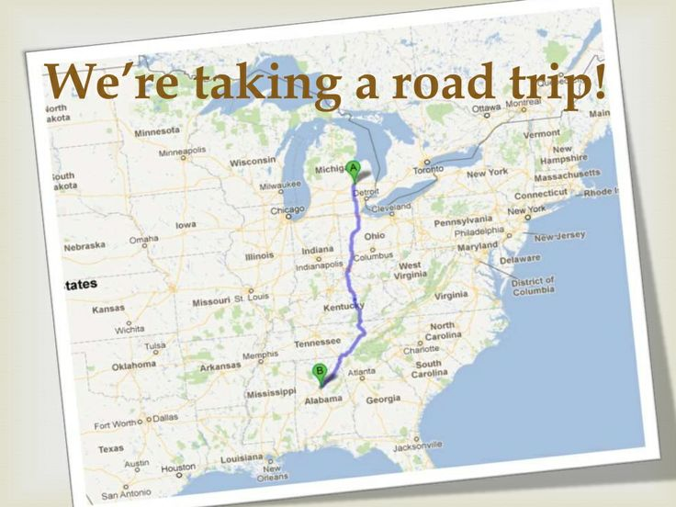

The Watsons go to Birmingham – 1963
Webquest

1960s Flashback – 1963

Explore the website and answer the following questions.

1. Who was the president?

2. Economy – What is the cost of a gallon of milk?
What is the cost of a gallon of gas?

3. Music – From the Billboard Top 10, name three songs you recognize or three songs that you think you might enjoy.

4. Movies – Choose one movie that you think you might enjoy and explain why.

5. Check out a few of the other categories and write down two interesting facts you have found.

The Watsons go to Birmingham – 1963
Webquest

Birmingham, Alabama

Explore the website and answer the following questions.

1. 2017 Birmingham Festivals – Check out this link and find a festival you think your family would enjoy. Why would you enjoy it? What would be your favorite thing to see or do?

2. Alabama State Parks – Check out the state park website. Choose one state park that looks enticing to you. Describe how you would spend a day at that park. Include at least three activities.

The Watsons go to Birmingham – 1963
Webquest

Jim Crow Laws
1. Where did the name “Jim Crow” come from?
2. List two facts you found interesting on this website.
3. Take the quiz at the end of the website. How did you do – be honest!

Civil Rights Leaders
Investigate one of the Civil Rights leaders on the website. Write a paragraph (at least five sentences) explaining who your person was and what your person did for civil rights.

The Watsons go to Birmingham – 1963
Webquest

16th Street Bombing

Explore the website and fill in the blanks.

1. The bombing took place at the church on September 15,

2. This was just three weeks after delivered his famous “I Have a Dream” speech.

3. The bomb went off as church members were attending

4. The four girls who died and one who was injured were found

5. The bomb was made out of

6. The four men responsible weren’t charged with the crime until which was years after the bombing.

7. In 2013, President awarded the Congressional Medal of Honor posthumously to

8. Posthumously probably means

The Watsons go to Birmingham – 1963
Webquest

Project!

You will create a PowerPoint Presentation including a picture and at least one complete sentence describing each. You may use any of the websites you have used already, or Google. You will end up with a total of 10 slides to present to the class:

1 – Title of book and your name
2 – Author and one interesting fact about him
3 – One interesting fact about the 1960s
4 – Famous people born in the 1960s (at least 3)
5 – Flint, Michigan, and an interesting fact
6 – Birmingham, Alabama, and an interesting fact
7 – An example of segregation, explain
8 – An example of a peaceful protest, explain
9 – Martin Luther King, Jr., and an interesting fact
10 – Do you think you will enjoy reading this book? Why or why not?

Good Luck Presenters!

